**Demonstrate a project to setup JDBC Environment(unassisted Practice)**

**Tomcat 8.5 ,Module 3.1**

**File paths**

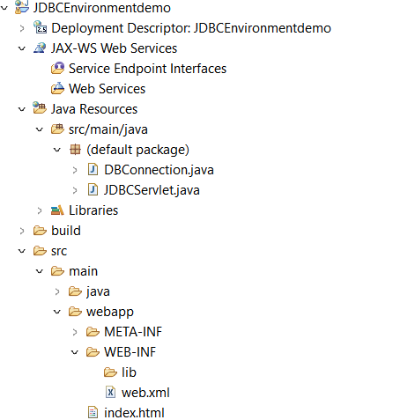

**DBConnection.java**

import java.sql.Connection;

import java.sql.DriverManager;

import java.sql.SQLException;

public class DBConnection {

private static final String *DRIVER_CLASS* = "com.mysql.jdbc.Driver";

private static final String *DB_URL* = "jdbc:mysql://localhost:3306/aruljothi";

private static final String *USERNAME* = "root";

private static final String *PASSWORD* = "root";

public static Connection getConnection() throws ClassNotFoundException, SQLException {

Class.*forName*(*DRIVER_CLASS*);

Connection connection = DriverManager.*getConnection*(*DB_URL*, *USERNAME*, *PASSWORD*);

return connection;

}

public static void closeConnection(Connection connection) {

try {

if (connection != null) {

connection.close();

}

} catch (SQLException e) {

e.printStackTrace();

}

}

}

**JDBCServlet.java**

import java.io.IOException;

import java.io.PrintWriter;

import java.sql.Connection;

import java.sql.SQLException;

import javax.servlet.ServletException;

import javax.servlet.http.HttpServlet;

import javax.servlet.http.HttpServletRequest;

import javax.servlet.http.HttpServletResponse;

public class JDBCServlet extends HttpServlet {

private static final long serialVersionUID = 1L;

protected void doGet(HttpServletRequest request, HttpServletResponse response)

throws ServletException, IOException {

response.setContentType("text/html");

PrintWriter out = response.getWriter();

out.println("<html><body>");

try {

// Initialize JDBC connection

Connection connection = DBConnection.getConnection();

out.println("<h2>JDBC initialized successfully!</h2>");

// Close JDBC connection

DBConnection.closeConnection(connection);

out.println("<h2>JDBC connection closed!</h2>");

} catch (ClassNotFoundException | SQLException e) {

out.println("<h2>Error initializing JDBC: " + e.getMessage() + "</h2>");

}

out.println("</body></html>");

}

protected void doPost(HttpServletRequest request, HttpServletResponse response)

throws ServletException, IOException {

doGet(request, response);

}

}

**web.xml**

<?xml version=*"1.0"* encoding=*"UTF-8"*?>

<web-app xmlns:xsi=*"http://www.w3.org/2001/XMLSchema-instance"* xmlns=*"http://java.sun.com/xml/ns/javaee"* xsi:schemaLocation=*"http://java.sun.com/xml/ns/javaee http://java.sun.com/xml/ns/javaee/web-app_2_5.xsd"* id=*"WebApp_ID"* version=*"2.5"*>

<display-name>JDBCEnvironmentdemo</display-name>

<welcome-file-list>

<welcome-file>index.html</welcome-file>

<welcome-file>index.jsp</welcome-file>

<welcome-file>index.htm</welcome-file>

<welcome-file>default.html</welcome-file>

<welcome-file>default.jsp</welcome-file>

<welcome-file>default.htm</welcome-file>

</welcome-file-list>

<servlet>

<description></description>

<display-name>JDBCServlet</display-name>

<servlet-name>JDBCServlet</servlet-name>

<servlet-class>JDBCServlet</servlet-class>

</servlet>

<servlet-mapping>

<servlet-name>JDBCServlet</servlet-name>

<url-pattern>/JDBCServlet</url-pattern>

</servlet-mapping>

</web-app>

**index.html**

<!DOCTYPE html>

<html>

<head>

<meta charset=*"UTF-8"*>

<title>JDBC Setup</title>

</head>

<body>

<h1>Call Servlet</h1>

<a href=*"JDBCServlet"*>Click here to initialize JDBC</a>

</body>

</html>

**OUTPUT**

